Provision AWS VPC:

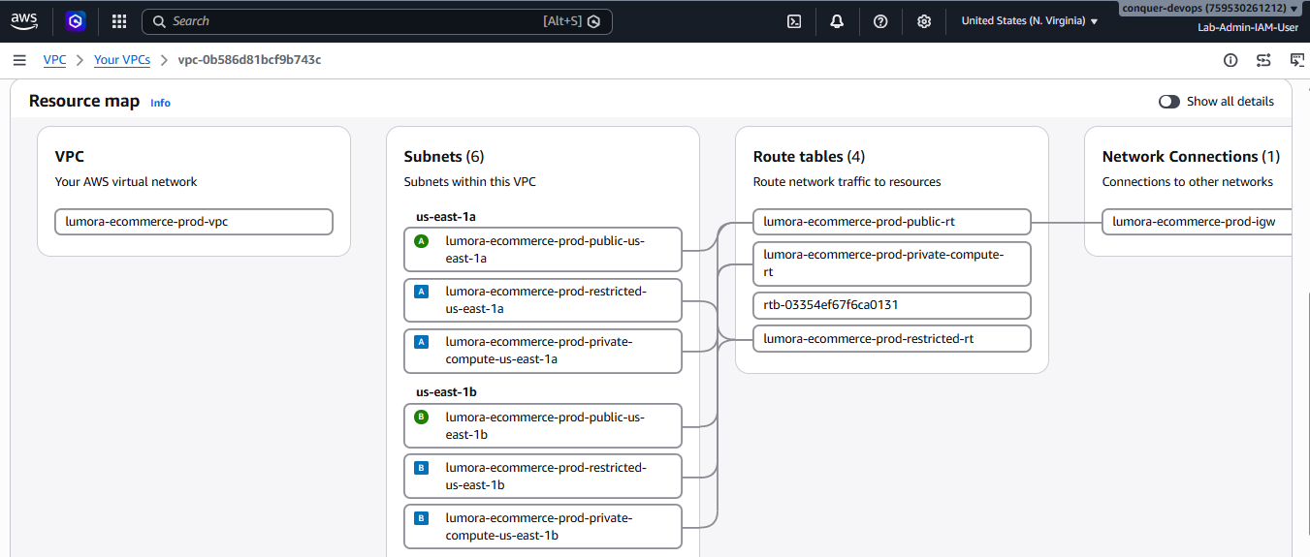

Configure Security Groups:

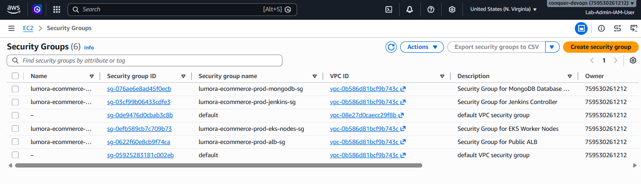

Povision EC2 server for Jenkins:
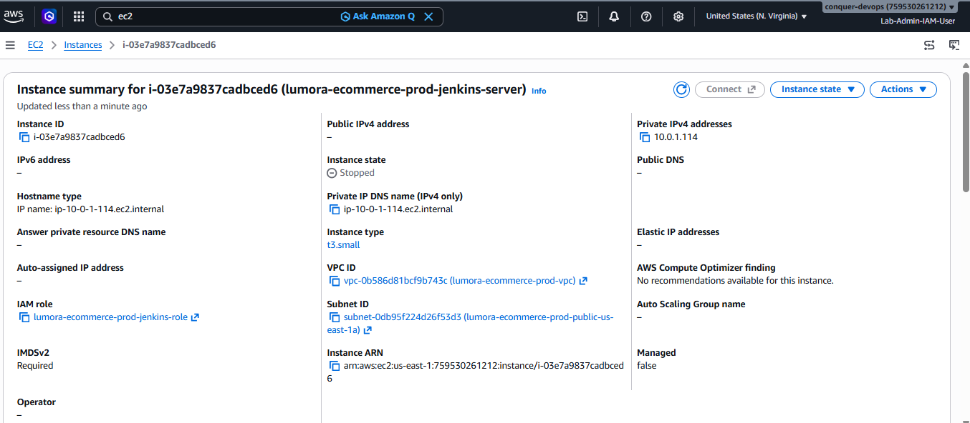

Create AWS ECR repository:
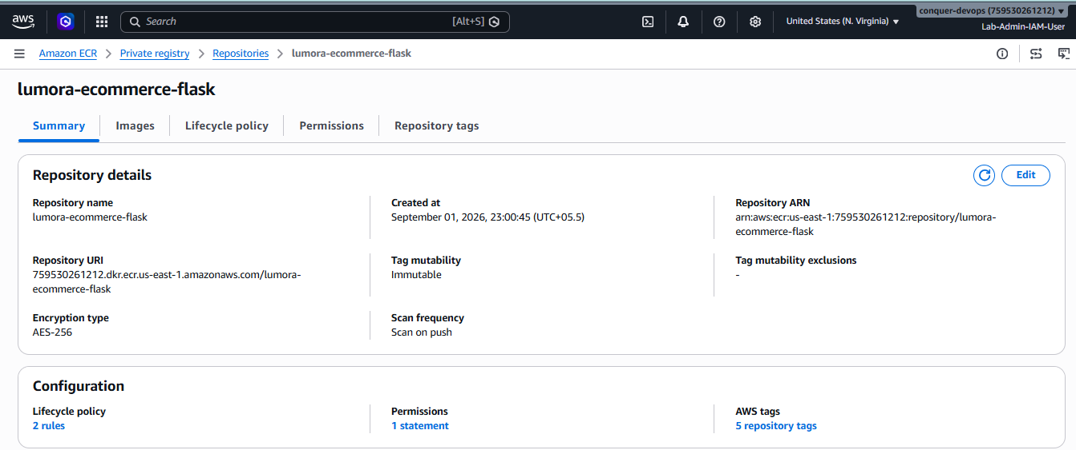

Jenkins pipeline build stages 1:
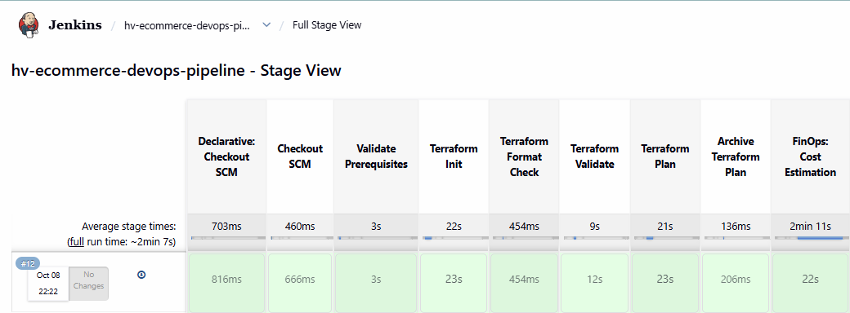

Jenkins pipeline build stages 2:
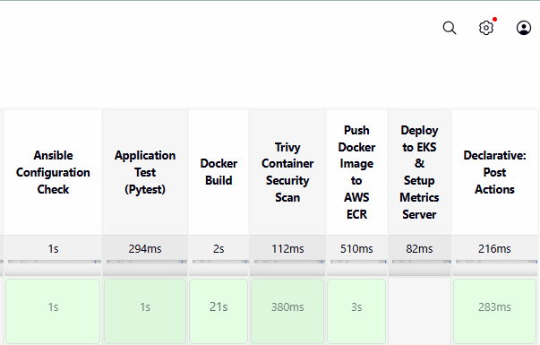

Flask Image in AWS ECR repository
